A
Mini Project
On
Business Performance Dashboard Using Tableau



Name of Student
Atharv Surendra Magdum

Name of University
Paris School of Technology and Business


Tech MBA

1. Introduction
Today, every business collects a large amount of data from daily operations like sales, orders, and customers. However, raw data in tables is often difficult to understand. A dashboard solves this problem by showing the same data in a visual and simple format using charts and graphs.
In this project, I created a Business Performance Dashboard that shows important details such as sales trends, profit, regional performance, top products, and customer segments. The main purpose of this dashboard is to make the data easy to read so that even a non-technical person can understand it quickly.
Instead of checking long data sheets, the dashboard gives a quick overview of the business in one place. This helps in saving time and making better decisions.

2. Objectives of the Project
The main objectives of this project are:
- To design a simple and clear dashboard for business analysis
- To study how sales change over time (growth or decline)
- To compare sales performance in different regions
- To understand which product categories are more profitable
- To find the top 10 products based on sales
- To analyze different types of customers and their contribution
- To present data in a visual and easy-to-understand format
- To help managers make quick and smart decisions

3. Tools and Technologies Used
This dashboard is created using a data visualization tool such as Tableau, Power BI, or Microsoft Excel.
Steps followed in this project:
- Data Collection – Collected the dataset containing sales details
- Data Cleaning – Removed missing values and corrected errors
- Data Organization – Arranged the data in proper format
- Data Visualization – Created charts and graphs
- Dashboard Design – Combined all visuals into one screen

Features used in the dashboard:
- Line chart for trend analysis
- Bar charts for comparison
- Simple colour coding for better understanding
- Labels and titles for clarity
These tools make the dashboard interactive and easy to use.

4. Data Description
The dataset used in this project contains sales transaction data of a company.
Important fields:
- Order Date – Shows when the order was placed
- Sales – Total revenue generated
- Profit – Earnings after deducting cost
- Region – Central, East, South, West
- Category – Furniture, Office Supplies, Technology
- Product Name – Name of the product
- Segment – Consumer, Corporate, Home Office

Data preparation process:
- Checked for missing values and removed them
- Corrected spelling and formatting errors
- Organized data into columns
- Ensured all values are accurate
This step is very important because wrong data can give wrong results.

5. Dashboard Components and Analysis

5.1 Sales Trend
This is a line chart that shows how sales change over time.
Observations:
- Sales are increasing year by year
- There are some ups and downs in between
- The highest sales are in the last year
Meaning:
This shows that the business is growing. The ups and downs may be due to seasonal demand or market changes.
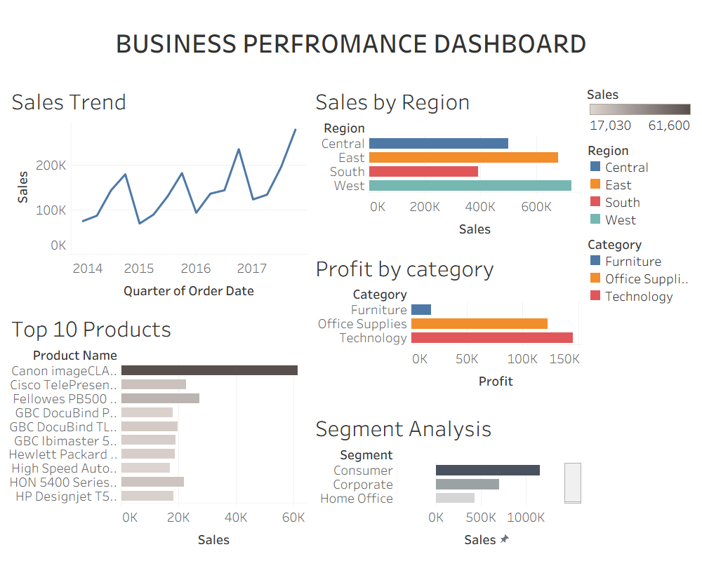

5.2 Sales by Region
This is a bar chart that compares sales in different regions.
Observations:
- West region has the highest sales
- East region is second
- Central region is average
- South region has the lowest sales
Meaning:
Some regions are performing better than others. The company can focus more on weaker regions to improve sales.

5.3 Profit by Category
This chart shows profit from different product categories.
Observations:
- Technology gives the highest profit
- Office Supplies give medium profit
- Furniture gives the lowest profit
Meaning:
The company earns more from Technology products. Furniture may need better pricing or cost control.
5.4 Top 10 Products
This bar chart shows the top 10 products with the highest sales.
Observations:
- A few products generate most of the sales
- One product is clearly the top performer
- Other products contribute less
Meaning:
The company should focus on these top products for marketing and stock management.

5.5 Segment Analysis
This chart shows sales based on customer types.
Observations:
- Consumer segment has the highest sales
- Corporate segment is second
- Home Office segment is lowest
Meaning:
The business depends mostly on regular customers (consumers). More focus can be given to growing other segments.

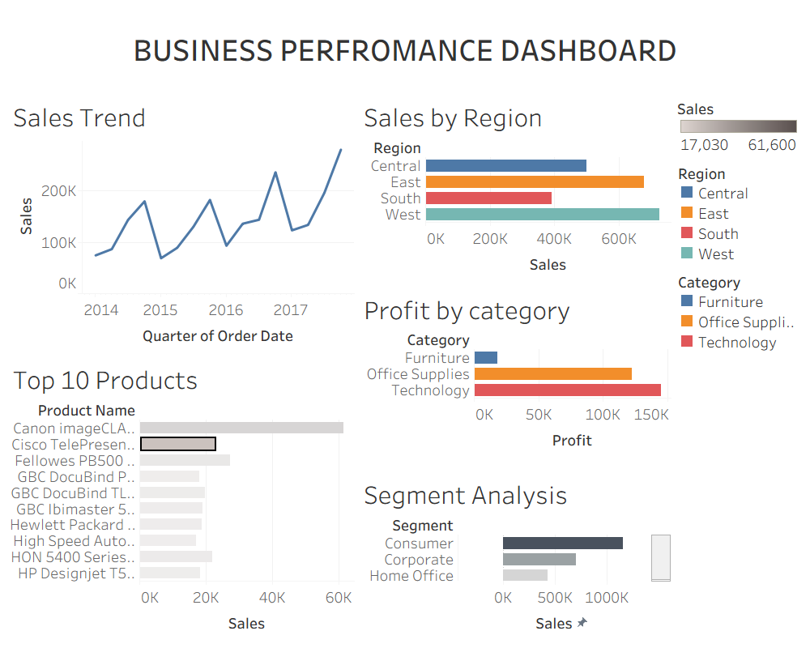

6. Key Insights
From this dashboard, we can clearly understand:
- Sales are growing over time
- West and East regions are strong markets
- Technology products give more profit
- Few products are responsible for major sales
- Consumer segment is the most important customer group
These insights help in improving business strategies.

7. Advantages of the Dashboard
- Easy to understand for anyone
- Saves time compared to manual analysis
- Shows clear trends and comparisons
- Helps in fast decision-making
- Gives a complete view of business in one screen

8. Limitations
- Depends on correct and complete data
- Cannot predict future automatically
- Does not include external factors like competition
- Needs regular updates for accuracy

9. Future Improvements
This project can be improved by:
- Adding future sales prediction
- Connecting to live data
- Adding filters for better interaction
- Including more KPIs like customer growth
- Making the dashboard more detailed

10. Conclusion
This project shows how a simple dashboard can make business data easy to understand. Instead of looking at complex tables, users can quickly see important information through charts.
The dashboard helps in understanding sales, profit, products, and customers. It is very useful for decision-making and planning.
Overall, this project proves that data visualization is very important for business success.

